DE03 ECG Machine Parameters
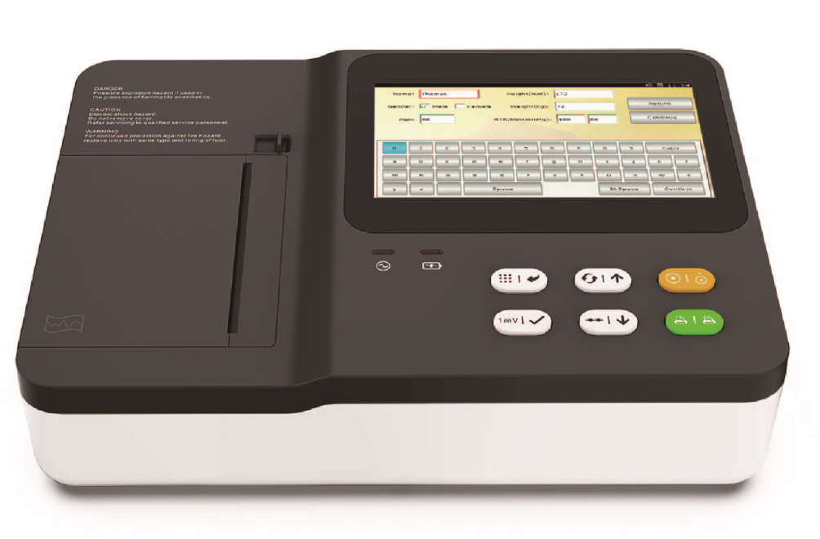
Functions & features
● 12-lead synchronous ECG acquisition；
● Equipped with high speed and high sensitivity hot spot recording system, with print trace depth adjustment function；
● 7-inch high-definition and wide-angle color LCD screen, capacitive touch control, 12-lead display;；
● Six ECG record combination modes；
● 3 channels/ (3+R) channels/dual-row 6-channels/single-row 6-channels/single/dual-row 12-channels six ECG display combination modes;
● Accurate ECG automatic diagnosis function, with heart rate exceeding alarm function, and freely set whether to print the measurement and analysis report；
● Full keyboard touch input to enter hospital and patient information；
● With real-time ECG waveform freezing function, it is easy to grasp the patient's important ECG waveform；
● Manual, automatic, rhythm, physical examination and other operating modes；
● With RS232 communication interface, USB interface and LAN network interface；
● External large capacity USB memory, can achieve the storage, playback and printing of historical data on the computer；
● Built-in large capacity any ion rechargeable battery, and a special charging circuit and perfect battery management and protection system；
● With lead off detection function, with paper shortage detection function；
● Wide power supply design, suitable for 110-230, 50/60hz ac power supply.
● Memory capacity can be expanded by USB flash disk.
★ Can be connected to the ECG workstation, with a strong patient file management function, can store up to hundreds of thousands of ECG reports；
★ With low power consumption mode, it can automatically enter standby mode or shut down after a certain period of inactivity；
★ High-resolution thermal dot matrix print output; baseline stability detection to ensure that neat and beautiful ECG wave forms can be printed every time；

Technical indicators

Common mode rejection ratio | ≥100dB
The input circuit | Float, defibrillation
Input loop current | ≤0.1чA
Sampling rate | 12bit/1000HZ
Operating mod | Manual/automatic
The filter | Power frequency filter, EMG filter
Drift filtering | Anti-drift system
The input impedance | ＞50MΩ
Patient leakage current | ＜10чA
Fuse specification | T1.6A/ 250V Ø5×20
Recording paper specification | Scroll/folding thermal recording paper (80mm)
Calibration voltage | 1mV±3%
Polarization resistance voltage | ±500m V
Time constant | ≥3.2s
Frequency response | 0.05Hz ～ 165Hz
Noise level | ≤15чVp-p
Minimum detection signal | ≤20чV
The feeding speed | 12.5 mm/s、25mm/s、 50mm/s
The sensitivity | 5，10，20 (mm/mV ±5 %)
Record | 3 channel high-resolution thermal printing
The battery | 10.8V/2.6Ah（28.08Wh）
Overall dimensions | 320mm×230mm×78mm | Net weight：1.85KG
Size of packing box | 390mm×300mm×215mm | Gross weight：4.5KG

